Janeka Martin
TCN2 — TCN2 Task 2: Data Exploration
Data Preparation and Exploration — D599

Part I: Univariate and Bivariate Statistical Analysis and Visualization
A. Using the provided dataset, do the following using R or Python:
1. Select four variables (e.g., two quantitative/numeric variables and two qualitative/categorical variables) and provide univariate visualizations for each variable selected.

Figure 1: Histogram of Score

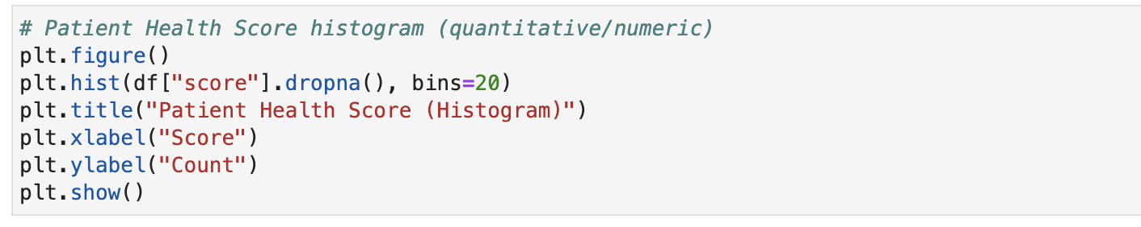
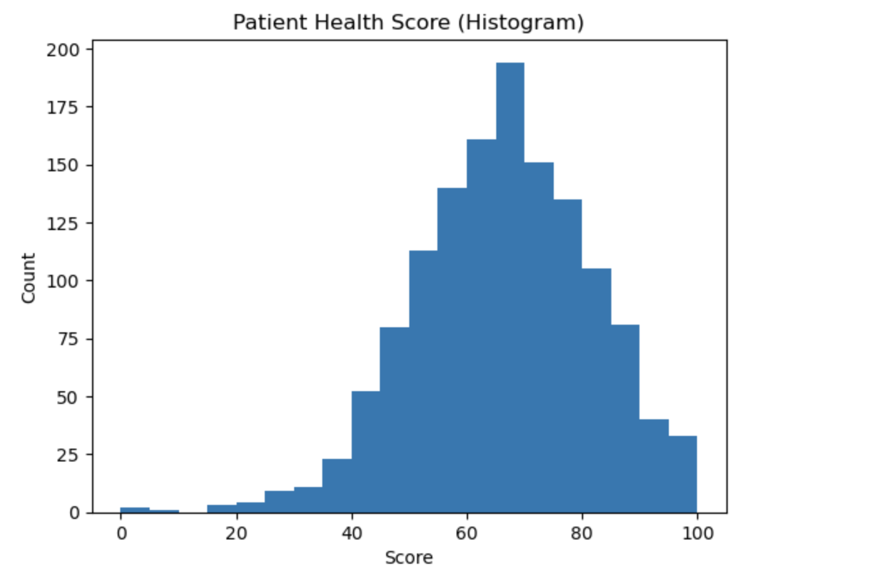

The univariate histogram below uses the continuous variable score and appears unimodal, with only one peak in the distribution (The University of Texas at Austin, n.d.). This single peak indicates that most patients cluster around a health score of 60-80. The distribution is slightly negatively skewed, as a small number of lower health scores extend into the left tail. The mean score is approximately 66, and the median is close, suggesting near symmetry with mild skewness.

Figure 2: Histogram of BMI
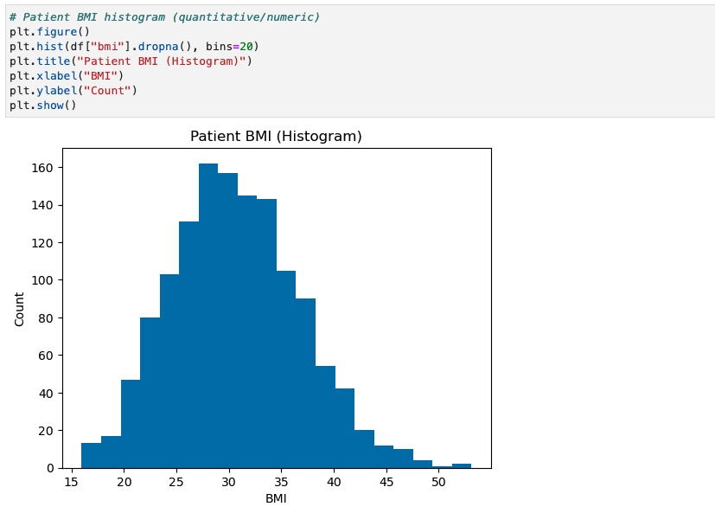

The univariate histogram of the continuous variable BMI appears unimodal, with a single primary peak. (University of Texas at Austin, n.d.). This peak indicates that most patients fall within a common BMI range. The distribution is slightly positively skewed, as the BMI values extend to the right tail, meaning a small number of patients have higher BMI values. The mean score is approximately 30.7, and the median is slightly lower; however, this still suggests near symmetry with mild skewness.

Figure 3: Bar Chart of Region

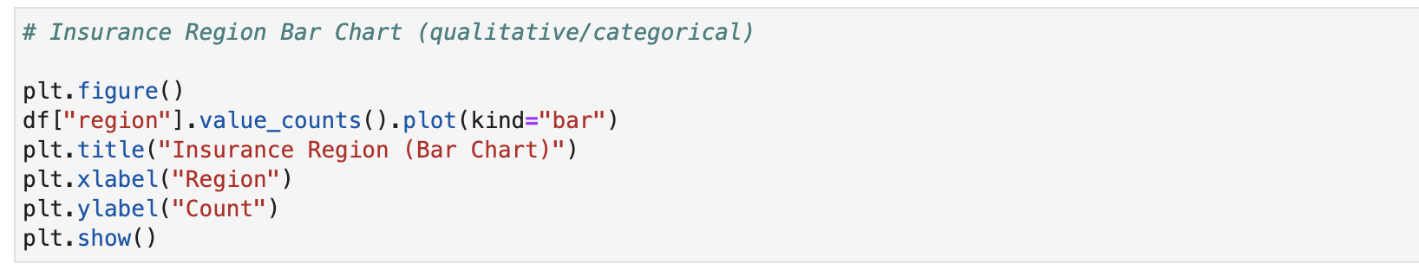
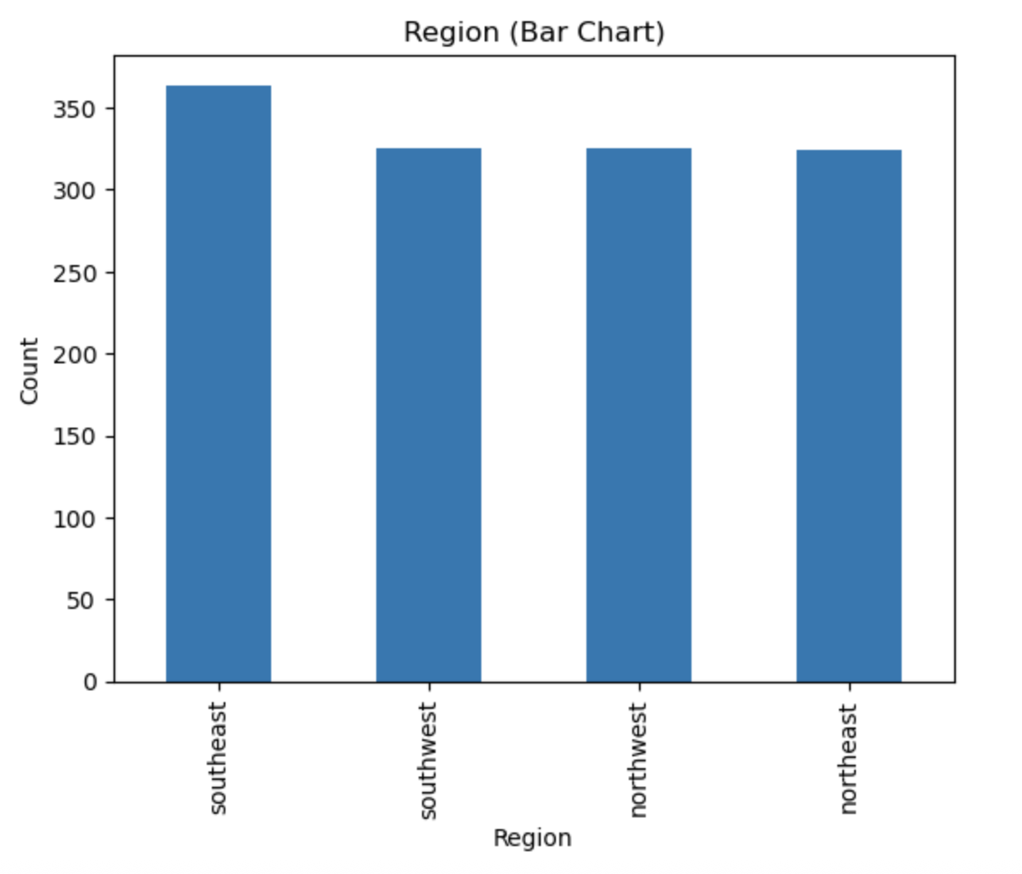

The bar chart for Region displays the distribution of patients across the four geographic areas: Southeast, Southwest, Northwest, and Northeast. The distribution appears relatively balanced, although the most common category (mode) is the Southeast. The Southeast has the highest patient count in the dataset. The remaining areas show similar but slightly lower proportions, suggesting a moderately even regional distribution overall.

Figure 4: Bar Chart of Level

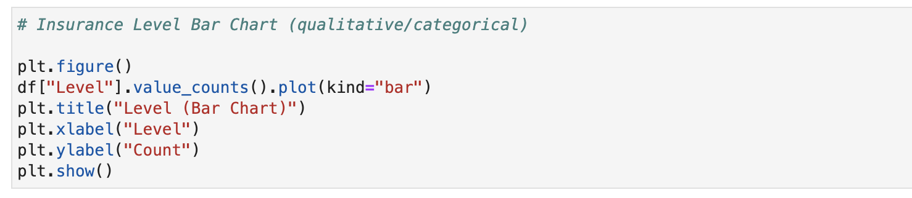
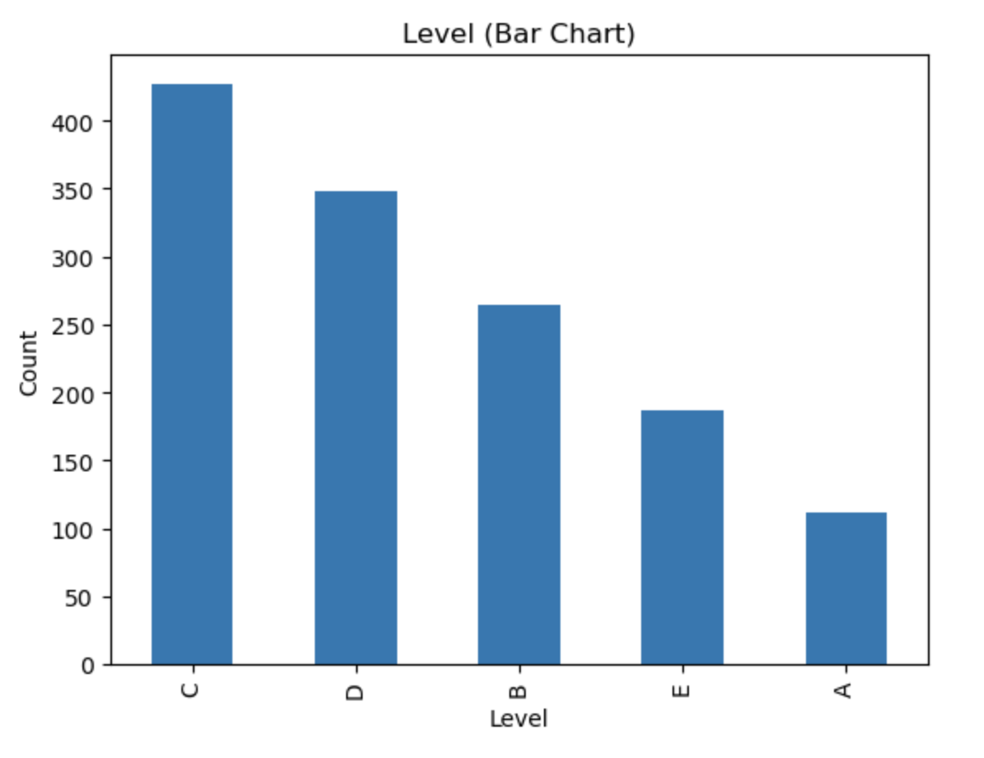
The bar chart for Level shows the distribution across the five insurance levels. The distribution is not uniform; the chart shows that Level C occurs most frequently, making it the mode of this categorical variable and accounting for the most significant proportion of patients in the dataset. The least common category is Level A, which represents the smallest proportion of patients in the dataset.

2. Provide two bivariate visualizations for each variable selected from part A1.

Figure 5: Scatterplot (Score vs BMI)
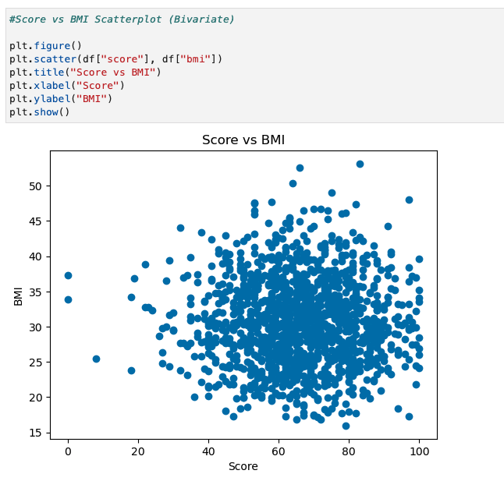
The scatterplot below illustrates the relationship between patient score and BMI. Overall, the points are clustered tightly, suggesting that there is not a strong linear relationship between the two variables. Most patients with health scores between 60 and 80 tend to fall within a BMI range of approximately 25 to 35, indicating that the majority of observations are concentrated in this common score and BMI range.
Figure 6: Stacked Bar Chart (Region vs Level)
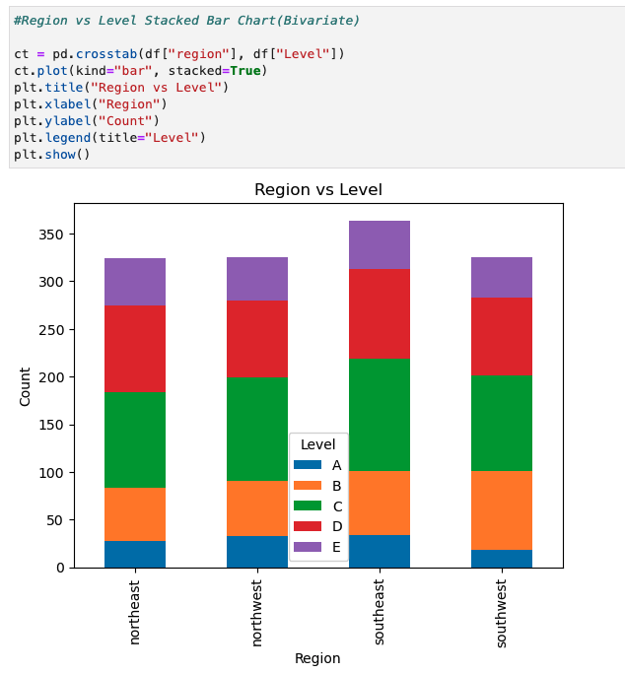
The stacked bar chart examines the relationship between Region and Level. This visualization shows that the Southeast Region has the highest number of patients overall. In addition, Level C appears to be the most frequent category across all regions, suggesting that this Level accounts for the largest proportion of patients regardless of geographic location.B. Complete the following using the attached “Health Insurance Dataset” and R or Python:

- Provide the descriptive statistics (e.g., mean, median, range, standard deviation, variance, percentiles, quartiles) for all quantitative (i.e., numeric) variables selected in the dataset.
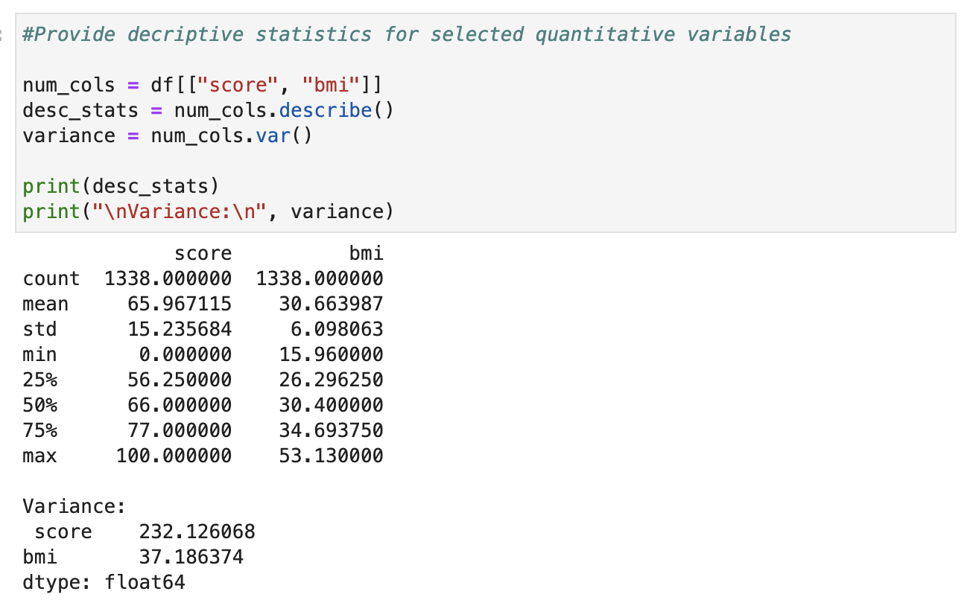
The descriptive statistics for the quantitative variables, score and BMI, summarize the dataset's center and variability. The mean health score is approximately 65.97, with a median of 66, indicating near symmetry in the distribution. Scores range from 0 to 100, with a standard deviation of 15.24 and a variance of 232.13, reflecting moderate variability in patient health outcomes. The mean BMI is approximately 30.66, with a median of 30.4. BMI values range from 15.96 to 53.13, with a standard deviation of 6.10 and a variance of 37.19. These statistics confirm that while patients cluster around average values, meaningful variation exists within the dataset.

- Provide the descriptive statistics (e.g., frequency counts and percentages) for all qualitative (i.e., categorical) variables in the dataset.
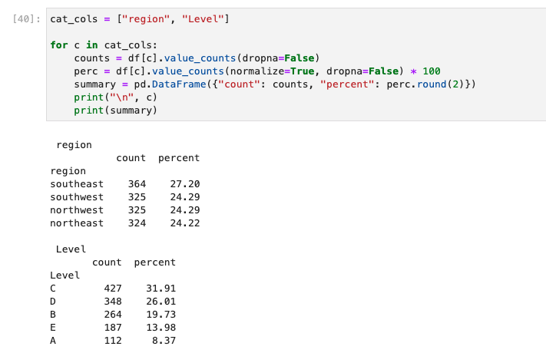

The descriptive statistics for the categorical variables region and Level provide both frequency counts and percentages. The Southeast accounts for the largest proportion of patients at 27.20%, while the remaining areas are relatively evenly distributed, each accounting for approximately 24% of the dataset. For the insurance plan level, Level C is the most common category at 31.91%, followed by Level D at 26.01%. Level A represents the smallest proportion at 8.37%. These distributions indicate that moderate-premium plans are the most commonly selected option and that enrollment is relatively balanced across geographic regions.

Part II: Parametric Statistical Testing
C. Describe a real-world organizational situation or issue in the attached “Health Insurance Dataset” by doing the following:

- Create one research question that is relevant to the dataset and any organizational needs that can be answered through data analysis and is appropriate for parametric testing.

Health insurance organizations could benefit from understanding whether patient scores are associated with health indicators such as BMI. This can support preventative care strategies and risk assessment.
Research Question: Is there a statistically significant relationship between patient BMI and health score?

D. Analyze the dataset by doing the following:

- Identify a parametric statistical test that is relevant to your research question from part C1.

The parametric statistical test used to answer this research question is the Pearson correlation test, which measures the strength and direction of a linear relationship between two continuous numerical variables.

2. List the dataset variables relevant to answering your research question from part C1.

The variables relevant to this test are:
- BMI (quantitative, continuous)
- Score (quantitative, continuous)

- Justify why you chose the statistical test identified in part D1 based on variables.

A Pearson correlation test is appropriate because both BMI and score are continuous quantitative variables. This test is designed to evaluate whether there is a linear relationship between two numeric variables, making it suitable for determining whether BMI is associated with patient health scores.

- Develop null and alternative hypotheses related to your chosen parametric test from part D1.

- Null Hypothesis (H0): There is no statistically significant relationship between BMI and health score.
- Alternative Hypothesis (Ha): There is a statistically significant relationship between BMI and health score.
5. Write error-free code in either Python or R to run the parametric test and provide the output and the results of all calculations from the parametric statistical test you perform.

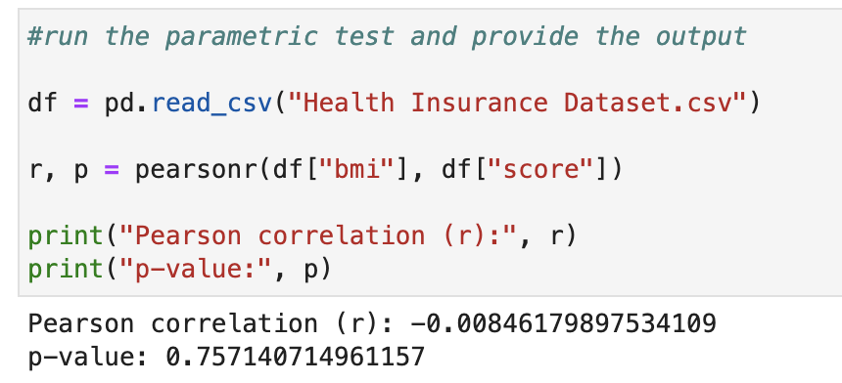
Note: Error-free code includes code that is free from syntax and logic errors.

E. Evaluate parametric test results by doing the following:

- Discuss the test results, including the decision to reject or fail to reject the null hypothesis from part D4.

The Pearson correlation test produced r = -0.008 and p = 0.757. The correlation coefficient indicates an extremely weak negative relationship between BMI and health score. However, because the p-value (0.757) is greater than the alpha level of 0.05, the result is not statistically significant. Therefore, I fail to reject the null hypothesis. There is insufficient evidence to conclude that a statistically significant linear relationship exists between BMI and health score.

- Create an answer to your research question from part C1 based on the decision to reject or fail to reject the null hypothesis.

Based on the Pearson correlation test, there is no statistically significant relationship between BMI and health score in this dataset.

- Explain how stakeholders in the organization benefit from your choice of testing method.

Stakeholders benefit from Pearson's correlation because it provides a precise, objective measure of the strength and direction of the relationship between BMI and health score. By using a parametric test designed for continuous variables, the organization can confidently determine whether a meaningful linear relationship exists. The results indicate an extremely weak, statistically insignificant relationship, suggesting that BMI alone does not meaningfully influence health scores in this dataset. As a result, stakeholders do not need to prioritize BMI as a primary metric when evaluating health score performance. They may instead focus on other factors that more strongly impact patient outcomes.

F. Summarize the implications of your parametric statistical testing by doing the following:
1. Recommend a course of action based on your findings.

Based on the findings, the organization should not prioritize BMI as a standalone predictor of health score within this dataset, as the Pearson correlation indicates no statistically significant linear relationship. Instead, stakeholders should explore other variables in the dataset, such as age, smoker status, charges, or insurance level, which may provide stronger explanatory value for health score outcomes. By reallocating analytical focus toward variables with greater predictive potential, the organization can better support risk assessment and strategic decision-making.

2. Discuss the limitations of your data analysis.
One limitation of this analysis is that Pearson's correlation coefficient measures only linear relationships between two continuous numerical variables. If a nonlinear relationship exists between BMI and health score, Pearson correlation would not detect it. Additionally, if a relationship was found between the variables, it would not establish that BMI directly causes changes in health score. Furthermore, other variables in the dataset, such as age, smoking status, or insurance level, may influence the health score and were not controlled for in this analysis. These limitations suggest that additional multivariate analysis may be beneficial for fully understanding the factors influencing patient health outcomes.

Note: One notebook can be submitted for both statistical tests.

Part III: Nonparametric Statistical Testing
G. Describe a real-world organizational situation or issue in the provided dataset by doing the following:
1. Create one research question that is relevant to the dataset and any organizational needs that can be answered through data analysis and is appropriate for nonparametric testing.

Research Question: Is there a statistically significant association between Region and Level?
H. Analyze the dataset further by doing the following:
1. Identify a nonparametric statistical test that is relevant to your question from part G1.

Chi-Square Test of Independence

- List the dataset variables relevant to answering your research question from part G1.
- Region (categorical)
- Level (categorical)

- Justify why you chose the statistical test identified in part H1 based on variables.

The Chi-square test of independence is appropriate because both Region and Level are categorical variables. This test evaluates whether there is a significant association between two variables. It is suitable for determining whether there is an association between geographic location and insurance plan level.

- Develop null and alternative hypotheses related to your chosen nonparametric test from part H1.

Null Hypothesis (H0): Region and Level are independent (no association).
Alternative Hypothesis (Ha): Region and Level are associated.

5. Write error-free code in either Python or R to run the nonparametric test and provide a screenshot of the output and the results of all calculations from the nonparametric statistical test you performed.

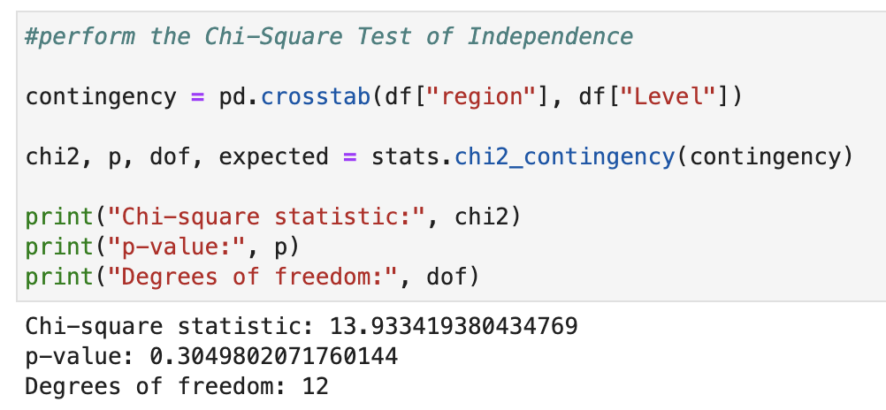
Note: Error-free code includes code that is free from syntax and logic errors.

I. Evaluate nonparametric test results by doing the following:
1. Discuss the test results, including the decision to reject or fail to reject the null hypothesis from part H4.

The Chi-square test of independence produced a chi-square statistic of 13.93 with a p-value of 0.305. Because the p-value (0.305) is greater than the alpha level of 0.05, I fail to reject the null hypothesis. Therefore, there is insufficient evidence to conclude that a statistically significant association exists between region and insurance plan level.

- Create an answer to your research question from part G1 based on the decision to reject or fail to reject the null hypothesis.

Based on the Chi-square test results, there is no statistically significant association between patient region and insurance plan level in this dataset.

- Explain how stakeholders in the organization benefit from your choice of testing method.

Stakeholders benefit from understanding that plan-level distribution does not vary significantly by region, suggesting consistent enrollment patterns across geographic markets.
J. Summarize the implications of your nonparametric statistical testing by doing the following:
1. Recommend a course of action based on your findings.

Based on the results of the Chi-square test, the organization does not need to implement region-specific strategies related to insurance plan level selection, as no statistically significant association was found between region and level. This suggests that plan distribution remains relatively consistent across geographic areas. Therefore, stakeholders may benefit more from focusing on other variables, such as age, smoker status, or healthcare charges, which may provide greater insight into plan selection patterns and risk segmentation. Redirecting analytical efforts toward more impactful variables can improve strategic decision-making and resource allocation.

2. Discuss the limitations of your data analysis.

One limitation of the Chi-square test of independence is that it only determines whether an association exists between categorical variables; it does not measure the strength or direction of the relationship. Additionally, the test does not account for other potential influencing variables, such as age or smoker status, which may impact insurance plan level selection. While the dataset has a sufficient sample size overall, uneven category distributions may affect expected cell counts. Future analyses incorporating multivariate methods may provide deeper insight into the factors influencing plan enrollment patterns.

Part IV: Panopto Video Submission
K. Submit your work by doing the following:

1. Provide a document that includes responses to task prompts through the Assessments section of the student portal.

This report includes responses to task prompts.

2. Provide the annotated code for Parts I, II, and III as an executable script file. R files and Python script files are accepted.

Link to code below:
https://gitlab.com/wgu-gitlab-environment/student-repos/jmart375/d599-data-preparation-and-exploration/-/blob/d3d21abfd257a74428c0cca0fe37b96933c56ec4/D599Task2.ipynb

Note: Error-free code includes code that is free from syntax and logic errors. Upload this file in the D599 Repository and name it “D599Task2.” Provide a link to the WGU GitLab repository that contains a copy of the executable script file using the R or Python language through the Assessments section of the student portal.

3. Provide a link to a Panopto video recording that includes a demonstration of the functionality of the code used for the analysis and an identification of the version of the programming environment. The demonstration must include a vocal presentation of all the listed elements.

Attached to this submission is the link to the Panopto video. The "Data Preparation and Exploration TCN2 | D599 (Student Creators)” expected location for the Panopto prompted for access, however, the video was saved under a previous class.

Note: One notebook must be submitted for Parts I, II, and III.

Note: The audiovisual recording should feature you visibly presenting the material (i.e., not in voiceover or embedded video) and should simultaneously capture both you and the functioning code.

Note: For instructions on how to access and use Panopto, use the "Panopto How-To Videos" web link provided below. To access Panopto's website, navigate to the web link titled "Panopto Access" and then choose to log in using the "WGU" option. If prompted, log in using your WGU student portal credentials, and then it will forward you to Panopto’s website.

To submit your recording, upload it to the Panopto drop box titled "Data Preparation and Exploration TCN2 | D599 (Student Creators)." Once the recording has been uploaded and processed in Panopto's system, retrieve the URL of the recording from Panopto and copy and paste it into the Links option. Upload the remaining task requirements using the Attachments option.

Sources
L. Acknowledge reference sources used to support the Python or R code application. All references listed should also include an in-text citation in the code annotation. Be sure the sources are reliable. If no sources were used for coding, state, “No sources used.”

No sources used.

M. Acknowledge sources, using in-text citations and references, for content that is quoted, paraphrased, or summarized.

The University of Texas at Austin (n.d.). Histogram. UTTexas.edu. https://sites.utexas.edu/sos/guided/descriptive/numericaldd/descriptiven2/histogram/

